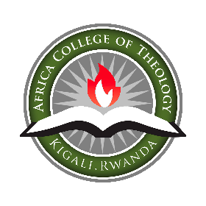

APPLICATION FORM

ALL PARTICULARS ON THE FORM MUST BE FILLED
Accurate information will insure prompt consideration. Please type this form or complete it neatly in ink, preferably black.
PERSONAL DETAILS

FULL NAME: ____________________ ________________________ ________________________
Family/Sir (Last) First Middle

Name(s) on previous records, if different from above_________________________________________

DATE OF BIRTH: ________ _________ ________ GENDER (Tick) Male [ ] Female [ ]
(Date) (Month) (Year)

NATIONALITY: Born in (country) _________________ Nationality: ________________________

Passport No: ____________________________________ ID No. ___________________

MOTHER & FATHER NAME:
Mother Name: _____________________________ Father Name: ___________________________

MARITAL STATUS (Check One):

[ ] Single [ ] Engaged [ ] Married [ ] Widowed [ ] Divorced [ ] Remarried

CURRENT CONTACT DETAILS

Postal Address ________________________ Code _________________________________
City/Town ____________________________ Country _______________________________
Telephone (Office) _____________________ Mobile ________________________________
Email ________________________________ Other email _____________________________

NEXT OF KIN/GUARDIAN (to be contacted in case of emergency)

Name _____________________________________ Relationship to applicant _________________________
Address ___________________________________ Telephone ________________________
Email _____________________________________ Mobile ___________________________

FINANCIAL BACKGROUND
Financial Resources: What is your anticipated source of income during your time at ACT?

Employment experience: List types of employment you have engaged in. position_______________________________
- .
- .
- .
If currently employed full-time, state your position _________________________________________________
Kindly check the appropriate figure representing your income per month.
- 50,000 – 100,000 Rwf
- 100,000 -200,000 Rwf
- 200,000 -300,000 Rwf
- 300,000 and above

Select your preferred intake:

[ ] January [ ] July Intended Year of Entry ___________________

Please indicate the program you wish to pursue at ACT (Tick [√] one)

[ ] Post-Graduate Diploma in Theology and Leadership
[ ] Bachelor of Arts(Hons) in Theology and Christian Leadership
[ ] Diploma in Bible and Theology

- PREVIOUS EDUCATION

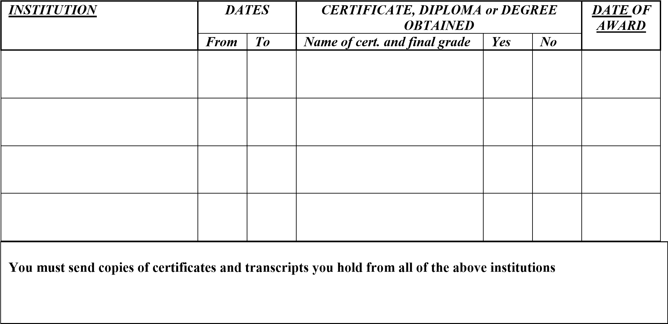

Please check what corresponds with your level of the language listed in the table below
Languages | English | French | Kinyarwanda
Can only read
Can read and write
Can read, write and Speak fluently
Cannot read nor hear

- ENROLLMENT INFORMATION: PLEASE SELECT YOUR PROGRAM OF CHOICE

CHURCH RELATIONSHIP

Name & address of a local church of which you are a member______________________________________
Street___________________City_________________Country____________
Phone____________________________________
Are you licensed? ___Yes ___No, Ordained? ___Yes ___No
List Christian service activities in which you have engaged in:
- ________________________________________
- ________________________________________
- ________________________________________
- ________________________________________

Please attach a brief statement regarding:

a. How you came to Christ.
b. Your Christian experience to date.
c. Your plans when you finish college at ACT.
d. Why you chose Africa College of Theology.

DOCTRINAL STATEMENT

The Bible, in its original documents, is the inspired Word of God and without error in its statements. There is only one God, eternally existent in three persons: Father, Son, and Holy Spirit; Creator of heaven and earth. The Lord Jesus Christ, born of a virgin, is fully God Who took on flesh, and being sinlesly perfect, gave Himself as a substitutionary sacrifice for our sins by shedding His blood and dying on the Cross; He then was raised from the dead. Man is saved by grace through faith; and none of man's efforts, regardless of how good or well-intended, before or after salvation, has anything to do with his salvation. Believers are looking forward to the imminent return of Jesus Christ.
The Trinity: We believe in one God, eternally existing in three persons – Father, Son, and Holy Spirit.
The Father: We believe that God the Father is a spiritual being, omnipotent, omniscient, holy, righteous, loving, and infinitely good; having life in Himself and giving life to all things.
The Son: We believe that Jesus Christ is true God and true man, the only begotten of the Father.
We believe in the bodily resurrection of the Lord Jesus; in His ascension to Heaven; in His present life as our High Priest and Advocate; and in His return.
The Holy Spirit: We believe in the supernatural manifestation of the Holy Spirit in and through the life of the believer; in His empowering and equipping for service and ministry and in His definite, yet progressive work of sanctification, commencing at the time of the new birth and continuing until the consummation of Salvation.

Sin and Salvation: We believe that God created man in His own image; that man sinned and thereby incurred the penalty of death, physical and spiritual; that all human beings inherit a sinful nature.
We believe that the Lord Jesus Christ died for our sins as a substitutionary sacrifice and that all who believe and trust in Him are justified on the grounds of His shed blood.
We believe that all who repent of their sin, receive Jesus Christ by faith as Savior and confess Him as Lord are born again of the Holy Spirit and thereby become children of God.
We believe in the resurrection of both the just and the unjust and in the eternal blessedness of the children of God.

Scripture: We believe in the scriptures of the Old and New Testaments in their original writing as fully inspired of God and accept them as the supreme and final authority for faith and life.

The Church: We believe that one true church is the whole company of those who have been redeemed by Jesus Christ and regenerated by the Holy Spirit; that the new birth and personal confession of Christ are therefore essentials of church membership and that the church n earth is the organism through which God says and does what He desires for His world.
We believe that the Lord Jesus Christ appointed two ordinances – Baptism and the Lord’s Supper – to be observed as acts of obedience and as perpetual witness to the cardinal facts of the Christian faith.

STATEMENT OF FAITH

- We believe the Bible to be the inspired and the only infallible, authoritative Word of God.
- We believe that there is one God, eternally existent in three persons: Father, Son, and Holy Spirit.
- We believe in the deity of Christ, in His virgin birth, in His sinless life, in His miracles, in His vicarious and atoning death through His shed blood, in His bodily resurrection, in His ascension to the right hand of the Father, in His present rule as Head of the Church, and in His personal return in power and glory.
- We believe that for the salvation of lost and sinful men, regeneration by the Holy Spirit is absolutely essential.
- We believe in the present ministry of the Holy Spirit, by who’s indwelling the Christian is enabled to live a godly life.
- We believe in the spiritual unity of believers in our Lord Jesus Christ, with equality across racial, gender, and class difference.

Are you in substantial agreement with the doctrinal position of Africa College of Theology?
___Yes ___No

REFERENCES
Full names | County/ Address | Tel. | Email

"I hereby make application to Africa College of Theology, and agree, if accepted, to cheerfully abide by all the rules and regulations of the college, and to cooperate in every respect in advancing the Christian testimony of Africa College of Theology."
Signature of Applicant____________________________________Date________________

Important!
Please Attach:

a. Application fee of 25000 Rfw
b. Recent passport photos (three copies)
c) Pastors’ recommendation letter
d) Bank slips should be taken to ACT Business Office
e) Notarised copies of transcripts and certificates for your previous Education.
Note. All foreign qualifications should go through Rwandan qualification frame work (Equivalence)

BANK DETAILS
- BANK OF KIGALI
- Bank Account: 00049-07776170-60
- Bank Name: ACT Local Operations

Send your application and other attachments to admissions@actrwanda.org

In signing this application, I promise, if accepted as a student, to be subject to rules and regulations of ACT.

I declare that all statements on this application are true to the best of my knowledge

SIGNATURE OF APPLICANT: _________________________ DATE: _______________
For Office use only: ____Application fee paid ____ Transcripts received ____ Photos____

